- ESP 32 CAM Settings:
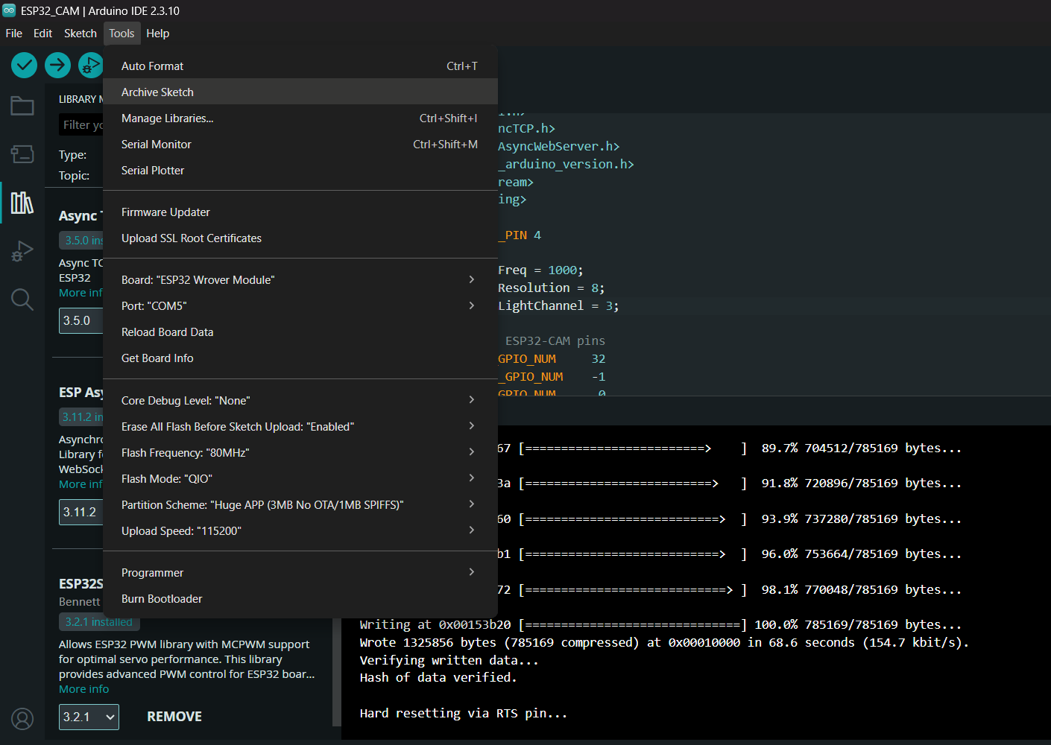

- ESP 32 Contoller:
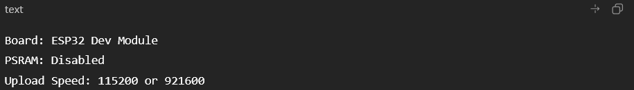

- LIbraries :

